CYBER SECURITY

A Project Report Submitted
for

Information Technology
By

OM UPADHYAY
(Roll no.24)

Under the guidance of
Mr. Praveen Kumar Joshi



EVER GREEN SENIOR SECONDARY SCHOOL
(GOVERNED BY EDUCATIONAL WELFARE SOCIETY)
TULARAMPUR - 223139, DISTRICT-NAINITAL
UTTARAKHAND, INDIA

OCTOBER, 2021

CERTIFICATE

This is to certify that the project entitled “CYBER SECURITY” being submitted to Evergeen Senior Secondary School, Haldwani for the project work of INFORMATION TECHNOLOGY is a record of the work carried by MR. PRAVEEN KUMAR JOSHI under my guidance and supervision.

Date: 11/10/2021 Supervisor
MR. PRAVEENJOSHI
TGT Computer
Ever Green Sr. Sec. School, Haldwani
Forwarded By:
MR. M.S. PARWAL
Principal
Ever Green Sr. Sec. School, Haldwani

ABSTRACT

Computer security, cybersecurity or information technology security is the protection of computer systems and networks from information disclosure, theft of or damage to their hardware, software, or electronic data, as well as from the disruption or misdirection of the services they provide.

Cyber security is the application of technologies, processes and controls to protect systems, networks, programs, devices and data from cyber attacks. It aims to reduce the risk of cyber attacks and protect against the unauthorised exploitation of systems, networks and technologies.

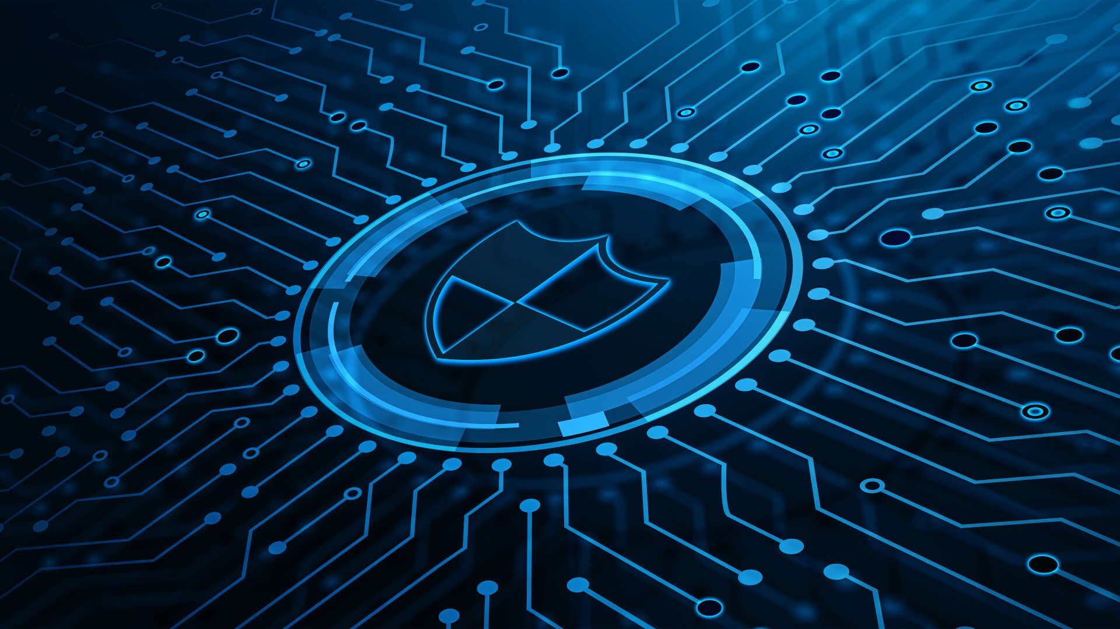

What are the types of cyber security?
Overview of the Types of Cyber Security
- Application Security. This is the process of protecting sensitive information at the app-level. ...
- Operational Security. ...
- Denial-of-Service Attacks. ...
- Malware. ...
- SQL Injection. ...
- Man-in-the-Middle Attack. ...
- Drive-By Downloads. ...
- Password Attack

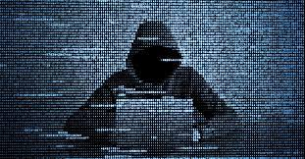

ACKNOWLEDGEMENTS
I would like to express my most sincere heartfelt gratitude and respect to my supervisor MR. PRAVEEN JOSHI, for suggesting the topic for my project work and for his excellent guidance, valuable suggestions and endless support throughout for preparing the report. I am greatly indebted to him for his constructive suggestions and criticism from time to time during the course of progress of my work.
I would like to express my gratitude and sincere thanks to Mr. M.S. Parwal, Principal of School, and entire faculty who has imparted considerable knowledge to me.
Finally, I express my deepest gratitude to my parents for their continuous encouragement, understanding and support.

(OM UPADHYAY)

TABLE OF CONTENTS

Chapter | Topic | Page No.
 | CERTIFICATE | 2
 | ACKNOWLEDGEMENT | 5
 | LIST OF FIGURES | 2
 | ABSTRACT | 3
1. | INTRODUCTION | 3

